[**The Complete Java Development Bootcamp**](https://capgemini.udemy.com/course/the-complete-java-development-bootcamp/)

**JShell** – It introduced java 9 version

* Jshell become a standard component of java developers kit in java 9 version.
* It was it known as Read-Eval-Print-Loop interactive program; it means it just pretty much just that:
* It reads the command or code segment we type in.
* It evaluates the execute the code, and often allows shortcuts to be used.
* It prints out the results of the evaluation or execution, without making the developer write the code to output the results.
* Lastly, it loops rights backs more input (more code segments or commands)
* Jshell runs in a terminal (or on the command line for windows) and is useful for quickly trying out new ideas.

<https://docs.oracle.com/en/java/javase/17/jshell/introduction-jshell.html>

Commands of jshell are:

1. **Jshell** – It shows us our jshell version.
2. **/Help** **intro** – This command gives simple introduction of the jshell.
3. **/Help -** For any assistance.
4. **/Exit –** This command helps us to exit the jshell.
5. **/Var –** Command in jshell can helps us to identify any misspellings have made.
6. 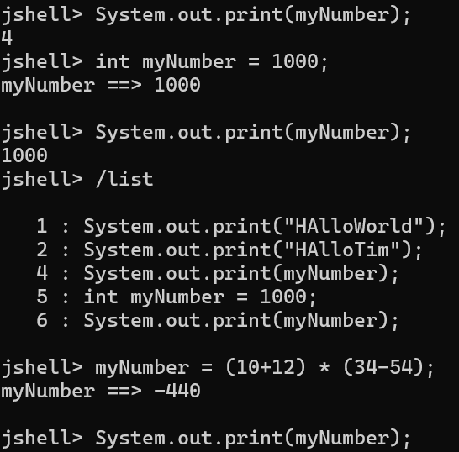**/List –** This command helps us to shows all the statements created in jshell.

By declaring a variable again, we are effectively re-declaring a variable, and in normal java programming, that would not be allowed and would throw an error.

Due to its interactive nature, Jshell “holds our hand”, and allows to redeclaration to occur without throwing an error.

**Operators** – Java operators are just operators, perform an operation on variable or value.

**Variables and keywords:**

**Keywords** – A keywork is any one of several reserved words, that have a predefined meaning in the java language. In java syntax, all code is case sensitive, and this includes keywords. As we’ll soon see, an **int**, all in lowercase, id not the same as **Int**, with a capital I. Here an **int**, (all in lowercase) is a keyword in java.

Take a quick look all the keywords in java using this link.  
<https://docs.oracle.com/javase/specs/jls/se17/html/jls-3.html#jls-3.9>

**Variables** – Well, variables are a way to store information in our computer.

Variables that we define in a program, can be **accessed by a name we give them**, and the computer does the hard work, of figuring out where they get stored, in the computer’s **random-access memory**, or RAM.

**Java code is a case sensitive** – This includes not only keywords and language syntax, but variable names and data types as well.

**Java primitive types:**

In java primitive types are the most basic data types. The 8 primitive data types in java. Listed by the type of data stored for each.

1. **Whole number –** byte, short, int, long
2. **Real numbers (floating point of decimal) –** float, double.
3. **Single character –** char
4. **Boolean value –** Boolean

Consider these types as the building blocks of data manipulation. Primitive data types are simply placeholders in memory for a value.

What is an integer?

* An integer is a whole number, meaning it does not contain a fractional element, or a decimal.
* There is a specified range of values allowed for the **int**, which is true for most data types.
* What this means is that the allowed range of values is not infinite.
* There is a defined minimum, and maximum value, for each numeric data type, meaning you can’t assign a number bigger or smaller (outside the range)